Dyson Home-Learning
Handed Out: 16.1.20 Due in: 21.1.20
KEY DATES / INFORMATION
23 Jan - Careers Day
30 Jan – Whole school trip – Cadbury World
5 Feb – Parent Coffee Morning (all parents welcome)
10 Feb – Reading Parent workshop – 9-10
10-14 Feb – Wellbeing Week
13 Feb – School Council Event – Cake Sale
14 Feb – Last Day of Term 3
Reading
Don’t forget to read five times a week. Remember Reading records will be checked daily.
PLEASE MAKE SURE READING RECORDS ARE IN SCHOOL EVERY DAY!
Spelling Rule:
This week’s spelling rule is words that have possessive apostrophe in plural words. Examples include - Girls’, boys’, babies’, flowers’, taps’, children’s, book’s, driver’s, plate and dog’s.
Please make sure that you and your parent write a comment at the end of your home learning- we want to know how you found it! Also, remember to check our Facebook page for regular updates on what your child has been learning in school!
Remember to continue using TT Rockstars. It is expected that you complete sessions at home as well as in school. Times tables are set through the children’s use of ‘Garage’ sessions. The software will automatically move children on depending on accuracy and speed. Remember to check in with Studio time as well.
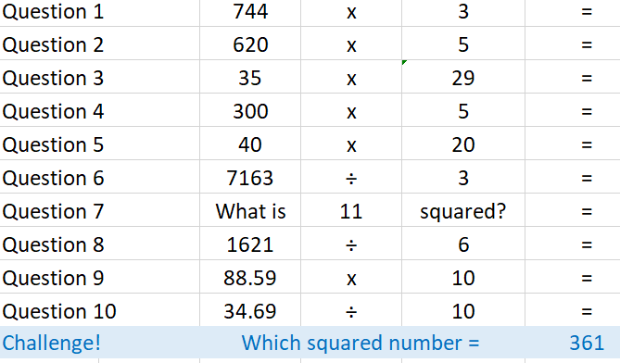
Think about which ones you can do mentally, which ones just need jottings and those that need formal written methods.

