Times Tables
Hints & Tips
for
Parents

Aspire - Believe - Achieve

What’s it about?
Parents often ask what they can do to help children at home with their maths – learning times tables is a brilliant way of helping your child and it really can make a huge difference to their confidence and ability.
You might remember standing up, chanting tables at school. Learning by rote is one strategy, but there are also other activities we can do with children to help them learn their tables. The aim of this booklet is to show you some strategies we use in school and that you could try at home to help children with their tables. We hope you find it useful.

Learning Times Tables
In the table below are the National Curriculum times tables expectations for each year group. The children will be tested on their times tables regularly in school. There is also a statutory times tables test that all children in Y4 will sit in the Summer term.
Useful Tips
- Stick to one table at a time to minimise confusion;
- Start with chanting and writing them out slowly in order;
- Then move on to completing the answers quickly in order – on paper or verbally with your child;
- Finally, move on to completing the answers in any order. o Keep reminding your child that 3 x 4 is the same as 4 x 3 – this is effectively halves the number of tables facts;
- Each table has a square number 3 x 3, 7 x 7 etc. These are special numbers that can act as a memory hook – emphasise them!
- Talk about the numbers as you are encountering them “5 x 7 = 35 that’s our house number” – this makes more memory hooks.
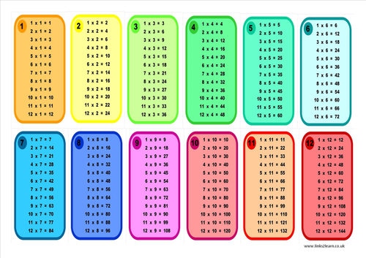

Don’t forget – your child has a unique log in for Times Tables Rockstars (www.ttrockstars.com) which is a fun way to increase fluency and speed in times tables. It can be played on laptops, tablets and mobile phones!
If you’re not sure about how this works, ask your child’s teacher for more information.

